**Zero discrimination day**

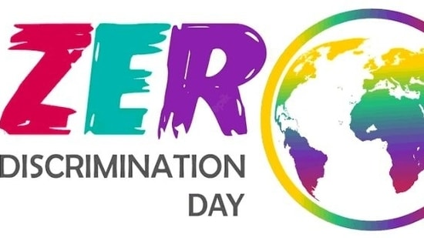

**We may have different religions, different languages, different coloured skin, but we all belong to one human race” and we cannot agree more as we try to imbibe this motto and use**[**love**](https://www.hindustantimes.com/topic/love)**as a cure or counter against the rising hatred and**[**discrimination**](https://www.hindustantimes.com/topic/discrimination)**in today's time, before it becomes a disease. Zero Discrimination Day is observed annually to promote**[**inclusion**](https://www.hindustantimes.com/topic/inclusion)**, equality,**[**peace**](https://www.hindustantimes.com/topic/peace)**and create awareness among people about their rights to live a peaceful life, address discrimination and its impact on individuals, communities and societies.**

**History:**

**The day was first celebrated on March 1, 2014 after UNAIDS, a joint United Nations program on Human Immunodeficiency Virus (HIV) and Acquired Immune Deficiency Syndrome (AIDS), launched its Zero Discrimination Campaign on 'World AIDS Day' in December 2013. The then-Executive Director of UNAIDS Michel Sidibé launched the day in 2014 with a major event in Beijing.**

## Significance:

**Zero Discrimination Day is celebrated to promote equality, inclusion, and tolerance across the globe. Discrimination in any form deeply impacts an individual. It also violates human rights, and creates barriers to access education, healthcare, and job opportunities, which eventually perpetuates poverty and inequality.**